Running Hello Program

These instructions demonstrate how to download and run the hello program on your EV3. You should have already installed all the necessary software on your computer and EV3 following the instructions on: <https://education.lego.com/en-us/support/mindstorms-ev3/python-for-ev3>

# Step 1: Start the Visual Studio Code application

* Verify that you see the LEGO® MINDSTORM® EV3 MicroPython extension installed.

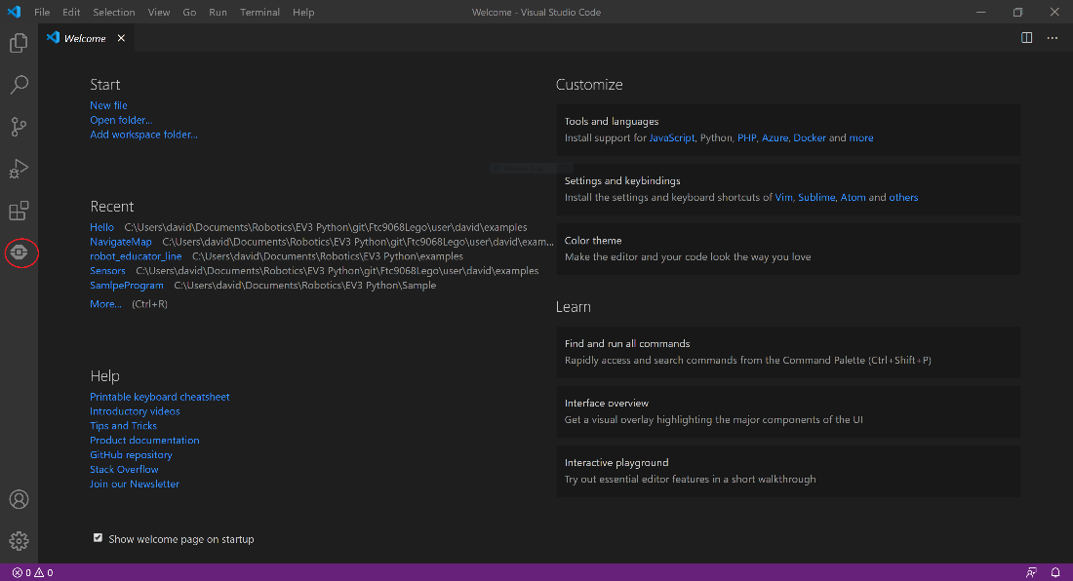

# Step 2: Open the Hello project folder

* Click on File -> Open Folder…

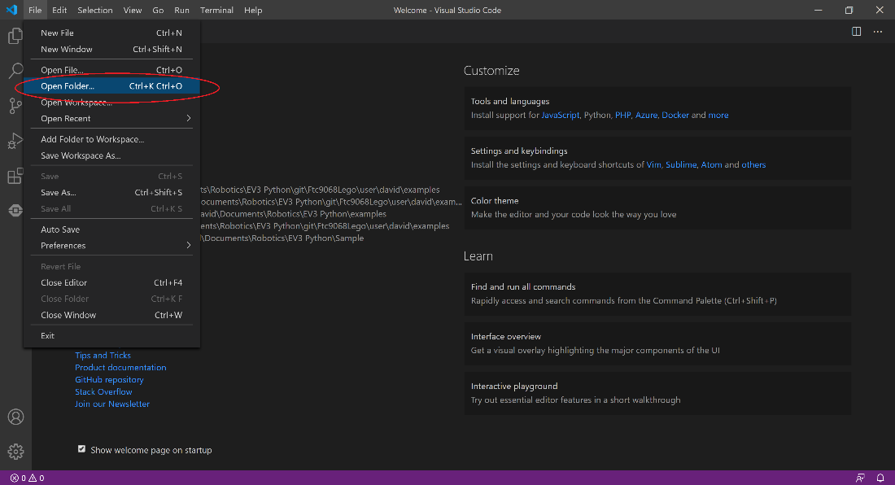

* Browse to the location where you saved the Hello project and select the folder.
* Click Select Folder

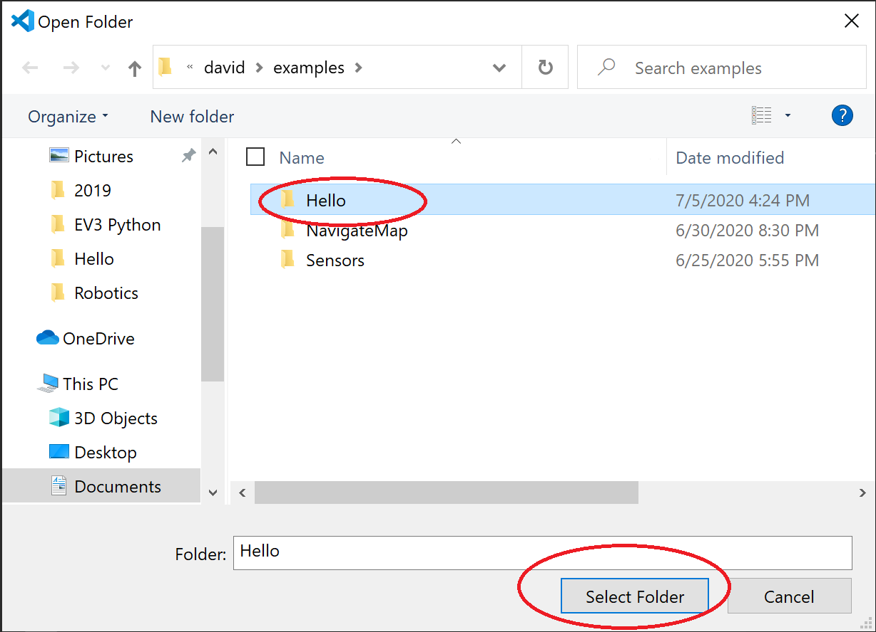

# Step 3: Power on the EV3 and connect to the computer

* Make sure the EV3 MicroPython SD card is installed in thee EV3.
* Turn on the EV3 and let it completely boot up. The light will turn green when it is ready.
* Connect the USB cable to the EV3 and to your computer.

# Step 4: Connect Visual Studio to the EV3

* Open EV3DEV DEVICE BROWSER
* Click on Click here to connect to a device.

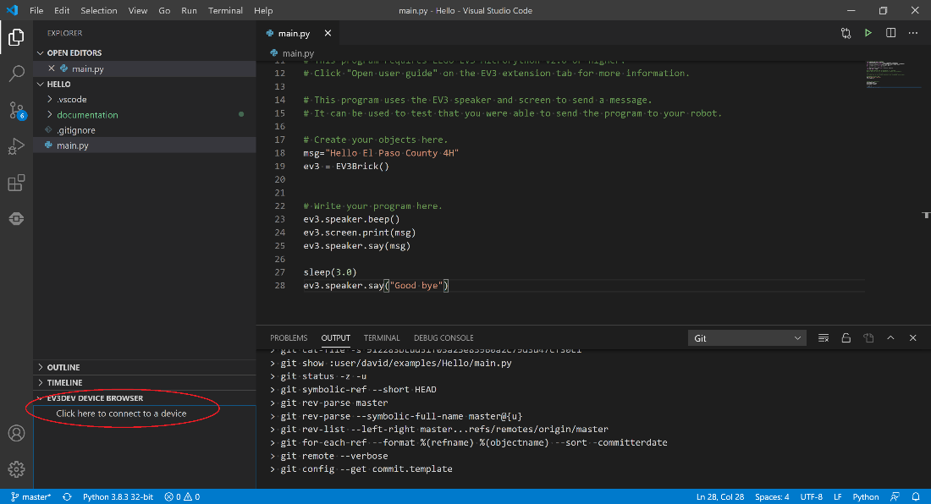

* Click on the connected device.

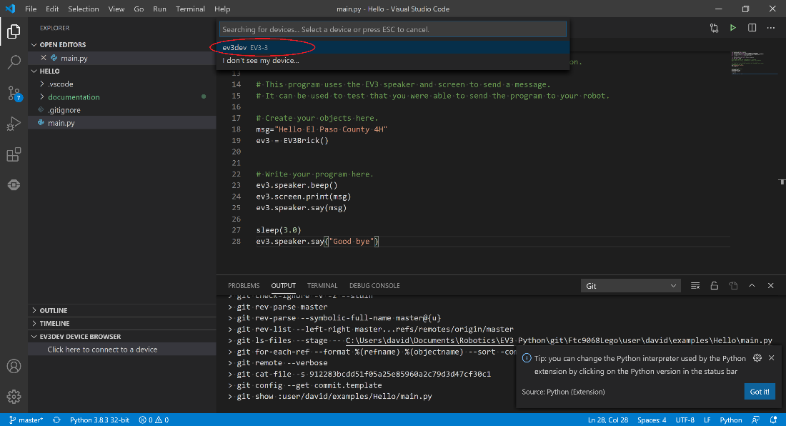

# Step 5: Download and run the Hello program

* Click on the run/debug symbol on the left of the screen.

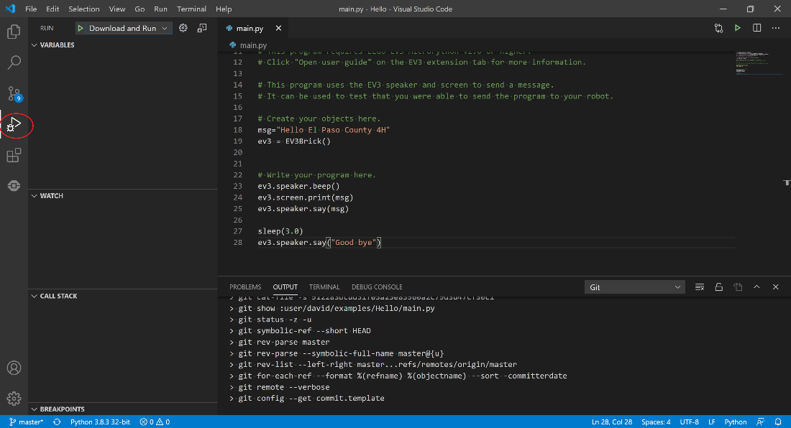

* Make sure the dropdown on the top of the screen is set to Download and Run
* Click on the green run triangle.

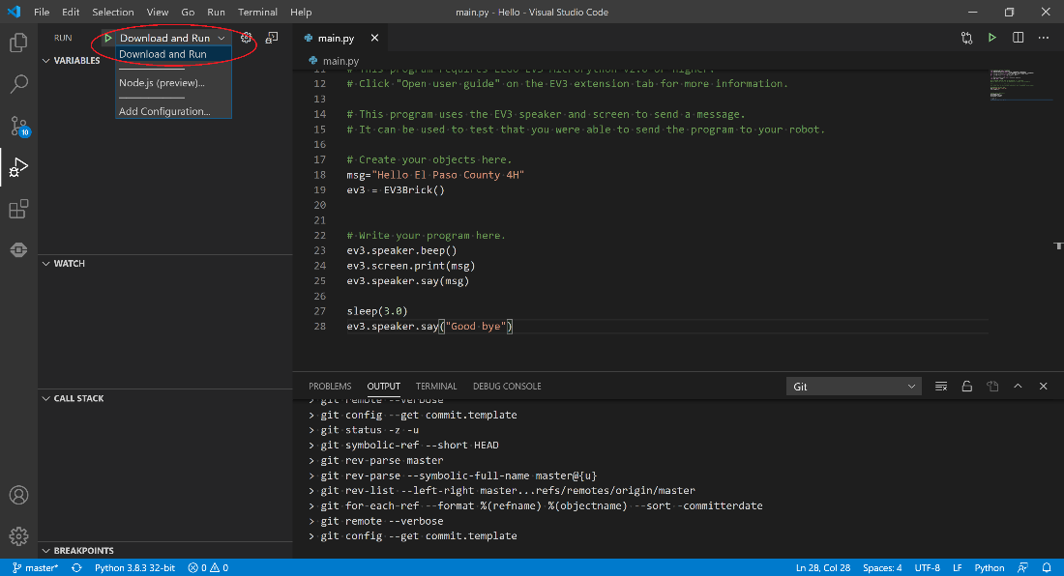

* Wait for the program to download and run. You should see a message on the EV3 screen and hear it speak.
* You can rerun the program on your EV3 using the File Browser option without being connected to your computer. Brows to the main.py file under the Hello directory.